University of Glasgow

Senate Meeting
1 February 2022

Library Annual Report 2020-2021

Susan Ashworth, Executive Director, Information Services & University Librarian
Martina McChrystal, Director of Library Services

Paper for Discussion

Brief Description of the Paper

Report on the Library’s activity for 2020-2021

Action Requested None

Recommended Person/s responsible for taking the action(s) forward N/A

Resource Implications (where appropriate) None

Timescale for Implementation (where appropriate) None

Sensitivity Implications (where appropriate) None

Equality Implications (where appropriate) None

INFORMATION SERVICES

LIBRARY ANNUAL REPORT 2020-2021

Susan Ashworth

Executive Director, Information Services & University Librarian

Martina McChrystal, Director of Library Services

Background

This report details service enhancements and delivery provided by two Directorates in Information Services, Library Services and Business Relationship Management.
This was a challenging year as Library services remained open throughout various protection levels in the course of the academic year and had to adapt and tailor services at short notice in response to changing Scottish Government guidance. This required a
complex balancing of service needs whilst maintaining a safe environment and managing occupancy as a key protective measure in study spaces. Communication with the University community was essential throughout the year to ensure students and staff could access buildings, resources and support.

Reduced occupancy and restricted access to collections were two of the major challenges during higher protection levels (Lockdown Level 4) from December 2020 until March 2021. New services offered to support the University during this time included Click and Collect and Scan and Send services for printed material; enhanced access to electronic resources; development of the UofG Life App which provided real time updates on occupancy in busy study spaces. The Main Library building reached full capacity most days during this period and there were often queues of students waiting to access study spaces.

Library teams were able to plan and review facilities, services and study spaces in July/ August 2021 in line with the Scottish Government move beyond Level 0 measures.
This enabled Library services to move away from a controlled occupancy management system. We received outstanding support from Estates colleagues, in particular the Health & Safety Team, in managing this transition and throughout differing levels of protective measures to ensure access and safety was maintained. We were also able to reopen some of our other greatly valued facilities, including the Prayer and Reflection rooms and the Library’s Family Study Lounge. In Archives and Special Collections, the team built on the success of the Virtual Collections Classroom which was developed over the course of last session to offer a full range of in-person, virtual and hybrid teaching sessions with the collections.

Our Photography team captured images of our campus throughout levels of protective measures and covered key moments throughout the year, including the opening of the James McCune Smith Learning Hub and the election of the new University Rector, Lady Rae QC.

Access to resources remained a critical part of our work throughout the year. The year saw challenging negotiations with publishers, which also led to a huge amount of modelling and scenario planning in preparation for potential sector walkway from big deals.

Maximising the value of our collections
The Library’s collections are global in reach and offer outstanding opportunities to the University community and external users for learning and teaching, research and discovery.
New acquisitions & cataloguing
Building on development work undertaken in the previous year, new accessioning procedures were implemented across the Library’s archival and manuscript collections, managed through our collection management system, EMu. In total, 22 accessions were received (19.2 linear metres and 4.1GB), with significant additions in particular to the University Archive and Scottish Theatre Archive.
The papers of the Scottish actor and comedian Johnny Beattie, who enjoyed a career in variety theatre and television spanning six decades, are a rich addition to the Scottish Theatre Archive.
Johnny Beattie. From Scottish Theatre Archive collection STA PH 516
For the University Archive, Malcolm Ferguson-Smith deposited further papers for his own Archive documenting his world-leading role in the development of modern genetics. Ferguson-Smith was the University’s first Burton Professor of Medical Genetics from his appointment in 1973 until his move to Cambridge University in 1987.

After several years of negotiation, we are also looking forward to the transfer of the records of Scottish Amicable, a collection which dates back to 1826. This is a significant addition to our collections focused on the Scottish financial industry which form an important part of the Scottish Business Archive at Glasgow. We were also delighted to secure ownership rights for the House of Fraser archive, a collection which had previously been held on deposit only. The collection is a rich resource for the study of retail, textile, urban and global history.
Working remotely for much of the year provided the opportunity for the ASC metadata team to focus on enhancing descriptive metadata to meet both professional standards and to enhance the functionality of our online discovery systems. Over 30,000 new descriptive records were created and 165,134 descriptive records enhanced. The catalogue of the archives of Whyte & MacKay, our priority cataloguing project, was published as well as the full catalogues of a number of business archives previously only partially discoverable online at collection level. In this, we were supported by students from the University’s Information Management & Preservation Masters course undertaking their cataloguing placement within the team.
This year we have also been involved in a number of new data sharing initiatives. We partnered with JSTOR to develop its Open Community Collections platform, contributing two digital collections. We exported our pre-1800 catalogue records to the Heritage of the Printed Book Database run by the Consortium of European Research Libraries (CERL), and all our 15th century catalogue data to the Material Evidence in Incunabula database, also operated by CERL.
Academic engagement
Archives and Special Collections teams continued to innovate to create and embed future facing online delivery models. Priority was given to the delivery of the Virtual Collection Classroom service to ensure a high-quality student experience despite restricted possibilities for interaction with the physical collection. 39 virtual classes were successfully delivered with three lecturers who used the services receiving teaching awards that referenced their use of this technology. While the overall number of sessions decreased by 56% from 88 sessions the previous year, the reach in terms of student numbers remained virtually the same as the previous pre-pandemic sessions (1186 from 1204). As we move into academic year 2022/23, a mixture of onsite, remote and hybrid teaching is now being delivered.

ASC Reading Rooms were staffed on a demand-led and risk-assessed basis, supporting research where access to the physical collection was essential. The Virtual Reading Room service, launched at the start of the semester, mitigated access limitations and allowed teaching staff to prepare classes remotely.

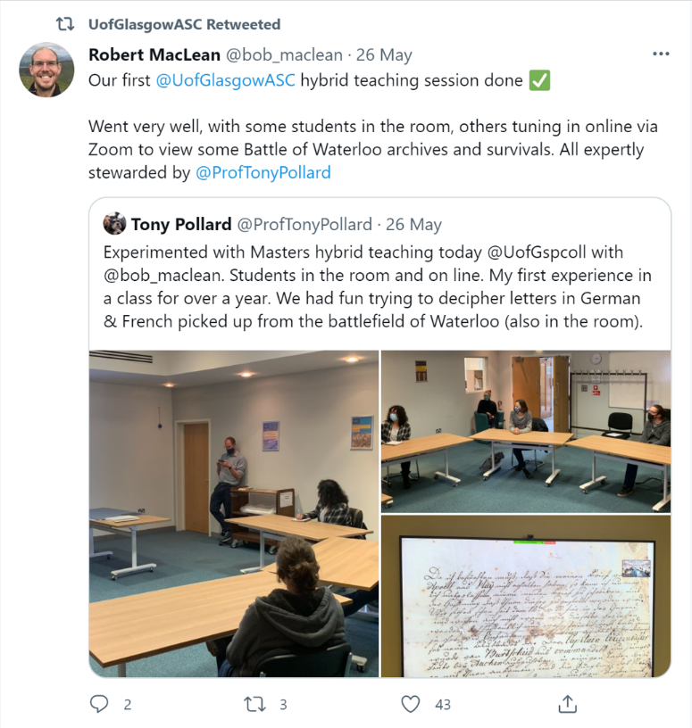
ASC Twitter post May 2021

In 2021 Information Services formally established a working group focused on issues surrounding Equality Diversity and Inclusion, following the University’s Understanding Racism, Transforming University Cultures report.

The group have been investigating how to address problematic language in our catalogues and collections and developing an online suite of materials in collaboration with the Stirling Maxwell Centre to illustrate how heritage collections can provide a platform for reframing and reinterpreting our colonial past.

Our highly valued student placement service was delivered fully online and remotely for the first time. Traditional placement models were revised to support remote working through item digitisation and virtual meetings to deliver placements. An innovative group model was also created with Information Studies to provide real cataloguing work experience at scale. It was successfully delivered for the first time to 50 students on the Masters in Information Management & Preservation Programme and will run again in 2022/23.

Collections Engagement

Exhibitions & Loans
Four rare and valuable Americana tracts from the Hunterian Library were loaned to The Box in Plymouth for ‘Mayflower: 400’, a ground-breaking exhibition which ran from June 2021 to January 2022, and which featured more than 300 objects drawn from museum, library and archive collections across the UK, USA and The Netherlands.

We were pleased to have 11 items from the Library’s collections featuring in the ‘Whistler: Art & Legacy’ exhibition at the Hunterian Art Gallery in July to October 2021, with the exhibition attracting over 15,000 visitors.

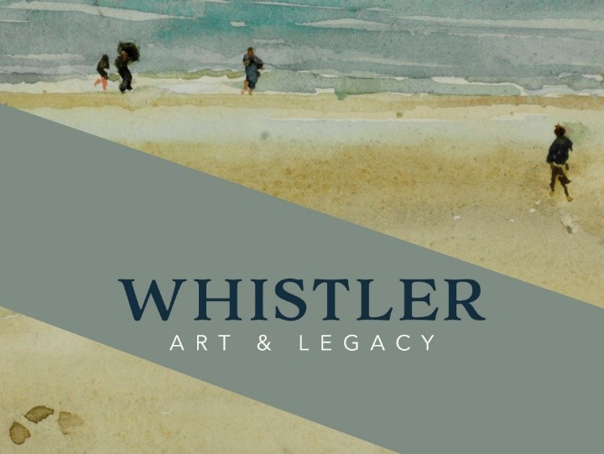

Digitisation
An important collection of correspondence and publications from the library of William Thomson, Lord Kelvin, was selected for inclusion in the Jisc supported ‘British Association for the Advancement of Science Digital Archive’. The Conservation Team surveyed, packed and sent over 3000 items by the publishers, John Wiley & Sons. Over 100 items were also assessed prepared for inhouse digitisation by the Photographic Unit, including 90 items for the Hunterian’s upcoming Mary Queen of Scots exhibition and MOOC.
Placements/student engagement
The team supervised two student projects focusing on MS Gen 1060 – an incomplete late 15th century Italian Bible, with unfinished miniatures. Polina Govorukhina, an MLitt Art History student, undertook a study of the manuscript’s artwork in a remote work placement resulting in a report and blog ; Rhett Leinster’s dissertation for the Mlitt Technical Art History programme researched and investigated the materials and methods used in the manuscript’s production via various technical analyses, including XRF, IRR and stereo-microscopy. The results from both projects will be incorporated into the current catalogue record in due course.

Rare Books outreach/engagement
ASC hosted the spring Association of Manuscripts and Archive Collections meeting as a virtual seminar in April 2021. ‘The Fifteenth-Century Book: Manuscripts in the early age of print’ featured six speakers focusing on ownership, engagement, scribes and materiality in both manuscripts and incunabula; the ASC visualiser was used to share books from our Hunterian Library in a live demonstration to a global audience of over 150, showing the potential applications of the new IT invested in during lockdown.

‘A Catalogue of Fifteenth-Century printed books in Glasgow Libraries and Museums’ is the culmination of the ten-year ASC Glasgow Incunabula Project. This two-volume printed version of the catalogue of our outstanding collection of c. 1000 incunabula was edited and compiled by Jack Baldwin and published by Boydell and Brewer in August 2020. Serving as a permanent record of the project research, this publication further extends the discoverability and knowledge of our collection worldwide. An informal virtual launch party to celebrate the book was held in June 2021; featuring several incunabula experts and a range of speakers who highlighted their favourite books from the catalogue.

Awards and grants
We were delighted to be awarded a grant from National Manuscript Conservation Trust grant for “From Mexico to Madrid: the conservation of University of Glasgow Library MS Hunter 242.” The Historia de Tlaxcala is a fascinating 16th century narrative history of the state of Tlaxcala in Mexico, accompanied by an illustrated chronicle of 156 drawings. Originally compiled by Diego Muñoz Camargo, the manuscript was presented to King Philip II of Spain as a diplomatic gift in 1584-85. Key to our understanding of the Spanish conquest of Mexico, the work is of international cultural and historical importance and has been in significant demand for research, teaching and exhibitions for many years, but access has been limited owing to its many conservation issues. The NMCT grant will enable us to embark on a conservation project to make the manuscript fully accessible again.

The team also contributed to the successful AHRC Capability for Collections Fund (CapCo) bid submitted by Christina Young of the Kelvin Centre for Conservation and Cultural Heritage Research. This interdisciplinary bid outlined the case for the acquisition of a range of technical equipment to facilitate conservation and cultural heritage research. For the library, this included a stereomicroscope with digital camera and live imaging software/PC for the conservation studio, and a portable microfader which will be used to risk assess light sensitive material requested for exhibition loans.

Collections Management
A key strategic strand of the ASC Conservation and Preservation Strategy, 2019-2024, is to improve the environmental conditions of our spaces whilst reducing our carbon footprint as much as possible. Work continued across the year on a Passivhaus project in our Thurso Street archive stores to increase stability of environmental conditions, improve resilience to air-handling units and reduce energy consumption. Results of the review are promising, with greater stability in terms of relative humidity in particular.

Collection care remained a priority for teams, with significant team resource allocated to supporting online/hybrid engagement and teaching with the collections, as well as facilitating access from estates to maintain and improve buildings and environmental conditions across the sites.
Interventive Conservation
Covid-19 restrictions meant that the Conservation team were working at home for some of the reporting period, which limited the amount of time available for interventive conservation. Nevertheless, treatment and associated research and documentation was completed for 27 items. Work is ongoing on another large conservation project, MS Hunter 223, a 14th century parchment manuscript. Approximately 75% of the work has been completed and will continue into 2021/22.
Collections Maintenance
The summer months provided an opportunity to undertake a monograph weed on level 5 of the library and the Dental and Vet branch libraries. This work is on-going but has already had a significant impact on capacity levels on level 5 and increasing the findability of items via Library Search. Work to review and weed the print journals collection was completed and titles identified for relegation to the Library Research Annexe or for discard are now being processed by the Collections Team. The outcome of this project should be a significant freeing up on space both within the Main Library and at the Library Research Annexe. The project also provided the opportunity to move some current subscription titles from print to online thus maximising access for learning and research.
SMLC Language Resource Library Relocation
The Language Resource Library, which was previously situated in the Hetherington building moved into the Main Library in 2021, following consultation by the School of Modern Languages & Cultures with students and staff. The move incorporated a new viewing room to enable staff and students to view recorded materials. The Reach Out College Library Support team are experienced in supporting and developing specialist libraries such as the James Herriot Vet Library and the James Ireland Memorial Library for the Dental School and bringing the SMLC Librarian into the team offers new and increased opportunities for SMLC staff and students to benefit from this expertise.

Supporting the student experience
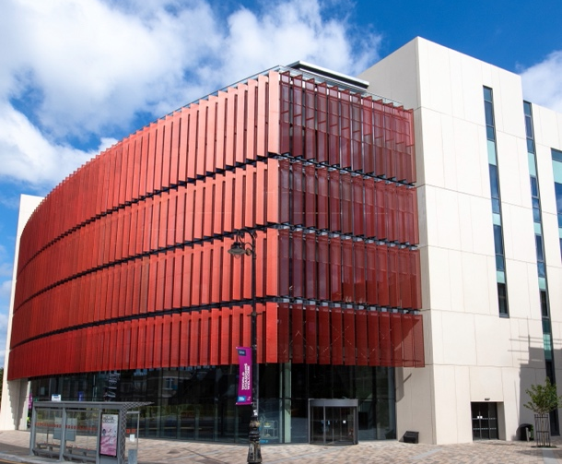
In April 2021, the James McCune Smith Learning Hub opened, offering a new study and learning and teaching experience in an innovative and flagship building. Users of the building have commented on the design, panoramic views, and the huge choice of social and quiet space. The building is designed to be porous and flexible. This of course posed some challenges in opening during protective measures. Occupancy management principles were well established and meant the building could open and operate safely throughout 2021. A new Reach Out Team was recruited to support students and staff in the building. The roving Reach Out model has proved highly effective and the Reach Out JMSLH team have built positive relationships with users of the building.
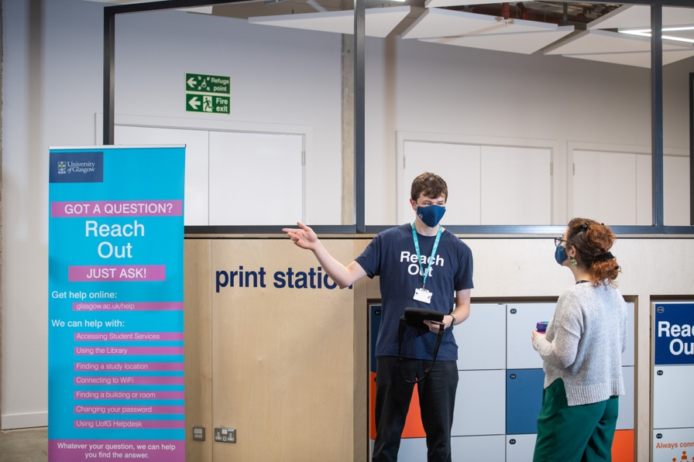
The Reach Out Team have worked in-person and virtually to support students over the past academic year, taking the best of the lessons learned during the first lockdown, and are now offering a blended model of support to students and staff, with services ranging from virtual one-to-one subject support meetings for PG students and in-person induction and training sessions, to simple enquiries about IT and Library services. Reach Out staff provide a friendly welcome to users of the Library and James McCune Smith Learning Hub and help students with general enquiries and accessing the main student services. The on-campus experience and the need for in-person support as well as robust virtual offerings has been key for students this year and we continue to see high levels of engagement with our on-campus teams.

The next phase of Reach Out involves delivering extended virtual and in-person support to Library users to match the service hours available to users of the JMSLH. Extended virtual support between 8am and 8pm has now launched and new Reach Out Ambassadors will be recruited to start delivering in-person support from early next year. Service improvement is built-in to Reach Out and the teams across all Reach Out locations work to develop and refine services in response to user feedback, in discussion with the SRC, and using data from UofG Helpdesk.
SCONUL Access
The SCONUL Access scheme and the British Library Inter-Library Loans service were both suspended during the pandemic in 2020, and both were reintroduced late in 2021. Reach Out staff are working closely with the British LibraryL and other partners to support our own researchers and the wider academic community across the UK.

Digital Infrastructure
Test and production servers which support the Library Management System (Sierra) were migrated to new virtual machines and operating system CentOS7 which will be supported until June 2024. The Sierra software followed the upgrade path to the latest version offered by the suppliers (Sierra 5.3). The Sierra client was also upgraded to incorporate a later version of java and was made available within Glasgow Anywhere. The Sierra system continued to support initiatives related to changing service demands including batch extension of due dates; click & collect requesting options; scan & send requesting integrated within Library Account; and integration of Law Workshop for circulation of print stock.

In related services, the self-check stations were upgraded to current models from Bibliotheca & 2CQR, and all stations accept MiFare authentication. The Staff/Student Portals are now using the Sierra API to pull details of current checkouts & holds into the portal without the need to login to Library Account. A range of system security improvements were introduced including https support for the WebBridge OpenURL resolver & a project (ongoing) to update http URLs for e-resource records held on Library systems to https.

Supporting Learning and Teaching
Work began early in the Summer to quickly secure access to key teaching resources for the new academic year. The Course Materials Policy , approved by the University’s Library Committee was implemented.

College Librarians led the Information Resources section of the online and hybrid accreditations of the School of Veterinary Medicine. This provided information on library services, IT, learning technology, and provided a good example of collaboration with colleagues across the School and Information Services.

The College Librarian team continue to provide expertise on procurement and training on learning resources to support online and blended teaching. A recent example includes
trialling and procuring online anatomy resources as a replacement for dissection labs, with the online equivalents continuing despite the gradual return to in-person teaching.

College Librarians collaborated with academic staff to facilitate synchronous and asynchronous learning sessions for UG, PGT and MRes students as well as providing fully accessible material for Moodle, including narrated PowerPoints and worksheets. The team offered live Q&A sessions as well as moderating discussion boards in Moodle.

The EdShare repository for teaching materials continues to provide an important service for academic staff, librarians and learning technologists looking to make their teaching content openly available.

Reading Lists @ Glasgow (RL@G) service and Course Materials in 2020-21
The RL@G service saw an increase of 17.5% in reading lists in 2020-21 with the focus of lists changing to ensure, where possible, that essential teaching materials were available online to support the University policy for Semester 1.
In response to meeting the changing requirements of the University for electronic teaching resources, the Library Materials Budget saw an increase of 68% in the Course Materials expenditure, while maintaining expenditure on key research resources for the Colleges.
Over 2,000 individual core eBooks were purchased via Reading Lists @ Glasgow to support teaching in the 2020-21 period, 67% of them on an unlimited access model. 33% of eBooks purchased for teaching had limited use licences. Additionally, the Library continued to invest in electronic textbooks, title by title via the aggregator Kortext, and collections via publishers such as Sage, Oxford University Press and Cambridge University Press.
The Library also expanded the service offering digitisation of course materials and the Reading List Team reported 35% more extracts digitised this academic year compared to the previous year (almost 5,000 book chapters for over 1,000 courses/modules).
Additionally, and to support further reading in the absence of purchasing this material, the Library subscribed to Academic Complete. This is a large-scale eBook collection offering access to nearly 200,000 multi-disciplinary eBooks. Subscriptions were also taken out to additional collections such as Scotland’s History Online (catalogue of Birlinn/John Donald) to support areas where eBooks were not previously available.
Usage for the 2 main e-book platforms for teaching has increased by 164% compared to the same period last year.
Support for research-resources
The Library Materials Budget received a further £134k investment from a Scottish Funding Council Grant to support research in 2020-21.

Resources supported directly by the grant were:
- 2 Patron Driven Acquisition programmes to directly support purchase of e- books for research purposes
- A large multi-disciplinary Oxford University Press research e-book package
- 2020-2021 subscription for Overleaf Commons
- Patron Driven Acquisition programme with Kanopy, specifically for research purposes

Additional resources to support research across disciplines were purchased towards the end of the financial year. These included:

- Churchill Archive The Churchill Archive gives full-text online access to Winston Churchill’s personal and official papers from 1874-1965.
- The Alexander Street Press Black Drama Database presents 1700 full-text plays from the 1850s to the present produced by North American, African, or Caribbean playwrights.
- The Supplementum Epigraphicum Graecum provides full text access to newly discovered Greek inscriptions with a related critical commentary.
- The British Series of Archaeological Reports gives new full-text access to 600+ key excavation reports which can be cross searched by topic.
- Gale Archives of Sexuality and Gender: LGBTQ history and culture since 1940 brings together primary source material including newsletters, papers, government documents, manuscripts, and pamphlets.
- SAGE Business Cases 2020 and 2021, supplementing existing collections from 2016 onwards. Includes over 4000 business cases supporting teaching and research.
- Digitised Chinese newspapers Jie Fang Jun Bao and Guangming Ribao supporting specialist research in Economic and Social History.
- Royal Geographical Society Wiley Digital Archive
- Edward Elgar e-book collections supporting Law and Economics
- Bloomsbury e-book collections supporting Law and Linguistics
- World Scientific Mathematics Digital Reference collections
- American Mathematical Society e-book collections
- Institute of Physics e-book collections

Big Deal Negotiations- Elsevier
The UK HE consortium have maintained a tough negotiating position with Elsevier over the year with a shared goal of achieving a sector wide Read and Publish Agreement which will achieve immediate Open Access to UK research, secure an overall reduction in cost, and is compliant with funder policies.

Public statements were issued from the Russell Group, University Alliance, Million Plus and GuildHE Research in strong support of this stance.
Elsevier issued a new proposal (the 7th) on the 29th of October 2021. Jisc indicated that this new proposal is far simpler, less costly and provides unlimited publishing in all eligible journals including the Cell Press and Lancet.
JISC have provided an evaluation of the new proposal to the Elsevier Negotiation Team and the Jisc UUK Content Negotiation Strategy Group, and the proposal is now out for consultation which closes on 31 January.
To help ensure the strongest possible negotiating position, the sector, including University of Glasgow, have been modelling alternative access options in order to maximise its stance with Elsevier and to be prepared should negotiations fail.

A major peer-to-peer approach to document supply is the N8+initiative. The University of Glasgow is a member of N8+ as part of the Scottish Confederation of University and Research Libraries (SCURL). The consortium has now expanded the scheme to include all libraries in Research Libraries UK. If a deal is agreed, this initiative will continue, taking forward valuable content collaboration and will benefit the UK sector as a whole.
Supporting Research
It has been another big year for open access with the REF exercise, the implementation of the new Wellcome Trust open access policy, discussions with other funders on future policy direction, and on-going work of supporting U of G research community to navigate and benefit from open access publishing.
Figures from Enlighten publications repository show a marked rise in the number of open access articles produced by U of G staff. This has risen from around 36% in 2014 to over 90% by 31st July 2021.
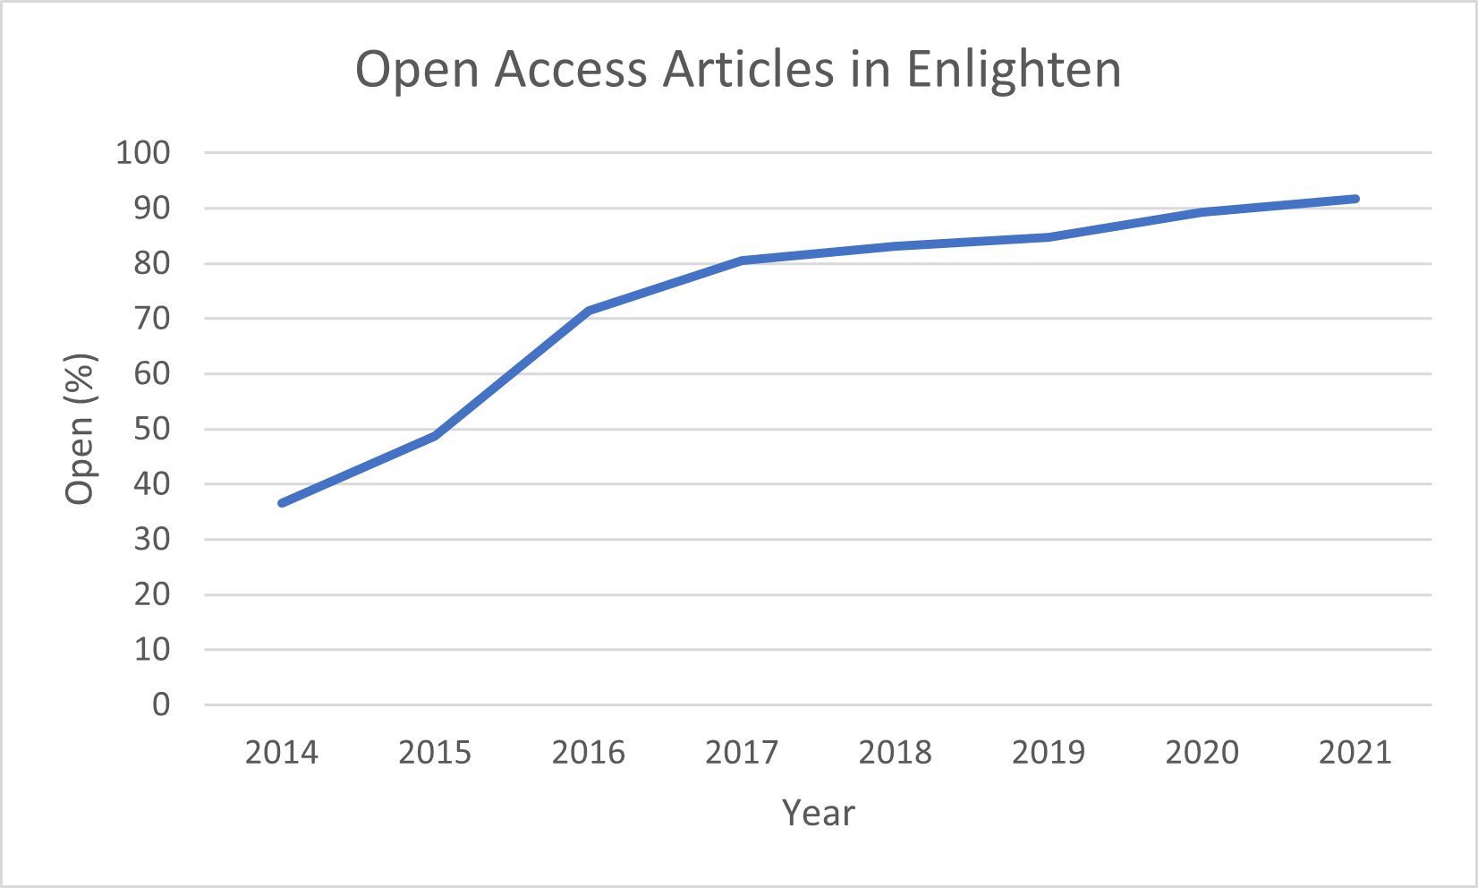
There have been extensive discussions about new and forthcoming funder open access policies. Library teams have ensured these have been communicated to our research community and are implementing systems and processes that make it as easy as possible for researchers to meet the new requirements. University of Glasgow have been catalysts for sector-wide discussions nationally and feed this learning and experience back into University of Glasgow processes.
The international and agnostic OA Books Toolkit was launched in September 2020. A member of the Research and Information Management team came up with the concept and was instrumental in its development as a founder member of the working group, and Editorial Advisory Group, through which further developments continue.
The RIM team assessed requirements to support the growing number of Open Access journals being created by university staff. A key outcome of this work was a new subscription to the Edinburgh Open Journals platform that will provide hosting and a permanent home for these university affiliated publications. (https://www.gla.ac.uk/myglasgow/openresearch/openaccess/establishopenaccessjournal/)
In 2022, Library teams will continue to work with Research Planning and Strategy Committee (RPSC), and colleagues in the School of Law, to investigate the best approach to rights retention for the University. There are several scenarios to facilitate posting of accepted manuscripts on repositories as a route to satisfy the new Wellcome Trust and UKRI open access policies and evaluation and support will be necessary.
Open Access is an ever-changing landscape which can be burdensome for our research community to navigate and understand. A key part of our on-going work is to take as much of this administrative burden away from researchers as we can.
REF 2021
REF was a significant event in 2021 and Library teams played an important role in promoting and managing the REF Open Access Policy ensuring high levels of policy compliance and robust processes for measuring and tracking compliance. Teams led on the engineering of REF data held across various university systems to produce current and accurate information for various stakeholders to action throughout the process and provided system support for the collection and submission of selected outputs.
The university submitted over 3270 outputs.

Research Data Management
Research funders and publishers routinely expect datasets that underpin research to be cited in publications and be easily accessible. The RDM service continues to provide a platform that makes this as easy as possible for our researchers. We continue to support researchers in managing their data, funder, and publisher expectations across the lifecycle from reviewing Data Management Plans at grant application stage to training staff and PGRs through formal Moodle and Zoom courses and ad-hoc advisory sessions.
The Introduction to Research Data Management training course continues to be delivered asynchronously through Moodle, with follow-up webinars. In the 2020-21 academic session, 610 PGRs completed the course.
The Data Management Planning training sessions are delivered monthly during term time through Zoom. We have customised our Data Management Planning tool ( https://dmponline.dcc.ac.uk/ ) so that it is badged as a University of Glasgow service and continues to provide both generic and university specific help for users.
Development wise, teams have been making improvements to the data repository infrastructure. This work had involved the development of new cloud storage with our external partners and the migration of some 3 Terabytes of university research data.
We have also continued collaboration with our peers across the UK and Europe through the Fairs Fair project and have been working as part of the Editorial Board and made a significant contribution to the publication of a Teaching and Training Handbook for FAIR Research Data Management ( https://zenodo.org/record/5787046#.YdhTZmjP2Uk )

Research Dashboard & Bibliometrics
There has been an increase in supporting Bibliometric use within the University, such as working with Social Sciences to help them shape a Research KPI and providing the PIA team with assistance around metrics for the University’s first submission to the Times Higher Impact Rankings.

College Librarians, working with Teams in Planning, Insights and Analytics (PIA) and Research Planning and Strategy Office, added and updated Scopus Author IDs in Enlighten. These IDs have enabled us to model the University’s structure within SciVal and to inform work developing a new Research Dashboard. This uses a wide range of metrics to evaluate the university’s research performance.

Looking ahead to AY2021-22 we are continuing to build on the work around supporting the REF, further deepening links with teams across the university to support research KPIs and advocating the use of responsible metrics.

Outreach and engagement

The digital shift provided an opportunity to engage with a wider audience with both academic and professional colleagues. Staff have been actively involved in national and international networks, sharing best practice, and exchanging experience and expertise with peers. These include Research Libraries UK, SCONUL, SCURL, ARMA, UKRI Interoperability Working Group, JSTOR, COAR, and CODATA RDM European initiative.

Information Services have continued their programme of Making Space for Kindness as part of Carnegie Trust’s Kindness Leadership Network. The Reach Out team as an example of kindness in the higher education sector continues to be important and the Reach Out senior team are actively engaged in discussions with Glasgow International College about embedding kindness in the curriculum and the wider student experience.

The Archives and Special Collections team presented a number of online events to showcase our collections:

September 2020: Doors Open Days Festival. Short film created by ASC/Library, subsequently added to UofG Scottish Literature Scottish Writers Moodle
Edwin Morgan | A Poet at the University of Glasgow - YouTube
March 2021: LGBT History Month event online with Edwin Morgan Trust, Louise Welsh, and EMT-commissioned artists.
https://www.eventbrite.co.uk/e/the-archive-and-a-queer-history-giving-edwin-morgans-work-a-second-life-tickets-142484624347
In March 2021, a successful application was made to The National Archives’ Covid-19 Fund to support a Scotland-wide repository of business records, with a particular focus on those sectors vulnerable to the economic impact of Covid-19. The 10-month project FIELDWORK: Mapping Scotland's Business Archives has been delivered jointly by the Ballast Trust and ASC with the Surveying Officer and Business Archives Cataloguer working on it throughout 2021.
The Performing the Archive LTDF partnership with Michael Bachmann in Theatre Studies continued this year with a series of workshops towards the creation of models for learning, addressing issues of accessibility, ‘archival anxiety’ and multiperspectivity in collection-based learning. A toolkit is in preparation for launch in 2022.

The team continue to provide archival support for Charlie Peevers and Maria Fletcher's Women in Law initiative which this year received an ESRC grant to investigate 'Creative Expression and Cultures of Progressive Change in Scotland: 100 years of Women in Law' which will look at the developments of the frameworks for inclusion of women in the legal profession.

A successful application to the Ferguson Bequest with Peggy Brunache and Laurence Grove was used to help the University take a fresh look at the Stirling Maxwell Collection at an event on St Andrews Day 2021.

SRC Virtual Library Space Group – the College Library team worked with SRC and IT colleagues enabling the provision of a library webcam offering views of the library off campus with very positive feedback.

R&D and Consultancy Projects
The Digital Curation Centre team were included in two proposals for Horizon Europe funding both of which would – if successful – see us continue our work to support the practical implementation of the FAIR Principles is support of realising the vision of the European Open Science Cloud.

The DCC has also been part of a consortium that successfully bid to carry out tender issued by the European Commission’s Directorate-General for Research and Innovation to undertake an assessment of the European research data landscape. The work is led by Visionary Analytics in Lithuania and other partners include European Future Innovation System (EFIS) Centre in Belgium, and Data Archiving and Networked Services (DANS) in the Netherlands. The work will run between June 2021 and May 2022.

Research Outputs & Publications
The collaboration with the Centre for Virus Research, which started in earnest in March 2020, has continued to prove fruitful, with our COVID-19 drug repurposing paper being published as a pre-print in March 2021. By the time of publication, the paper was not novel enough to reach post-peer-review publication, but the results provided valuable insights that were important in both in-vitro and clinical settings at the earlier stages of the pandemic. Further expertise has been provided on another COVID-19 paper in collaboration with CVR colleagues.

College Librarians peer reviewed journal articles on information literacy, information seeking and libraries for the Emerald journal Global Knowledge, Memory and Communication.

Baxter, G., Beard, L., Beattie, G., Blake, M., Greenhall, M., Lingstadt, K., Nixon, W. J. and Reimer, T. (2021) Covid-19 and the future of the digital shift amongst research libraries: an RLUK perspective in context. New Review of Academic Librarianship, 27(3), pp. 322-348. (doi: 10.1080/13614533.2021.1976232)

Chew, C., Cannon, P. and O'Dwyer, P. J. (2020) Radiology for medical students (1925-2018): an overview. BJR Open, 2(1), 20190050. (doi: 10.1259/bjro.20190050)

Clark, E., Maguire, H., Cannon, P. and Leung, E. Y.L. (2021) The effects of physical
activity, fast-mimicking diet and psychological interventions on cancer
survival: a systematic review and meta-analysis of randomized controlled
trials. Complementary Therapies in Medicine, 57, 102654. (doi: 10.1016/j.ctim.2020.102654)

Ivanova, Y., Aitchison, I., Cannon, P. , Butler, D., Gadegaard, N. and Keith, N. (2020) Mapping of University Research Output and Impact to the United Nations Sustainable Development Goals. Project Report. OSF. (doi: 10.17605/OSF.IO/UFYTA).

Communications and Connections
In 2021, the Information Services Communications Team employed a range of traditional and digital channels to keep Library users informed, engaged and safe. Throughout the year, the team led a campaign to encourage users of our Libraries and study spaces to follow Covid safety requirements on campus. This involved creating social media content and printed materials, launching a Tannoy announcement reminder system, and collaborating with the central Student Communications team to push messages through key central channels.

James McCune Smith Learning Hub
The Information Services Communications Team supported the launch of the James McCune Smith Learning Hub in April 2021, communicating important operational messages to building users and sharing user feedback.

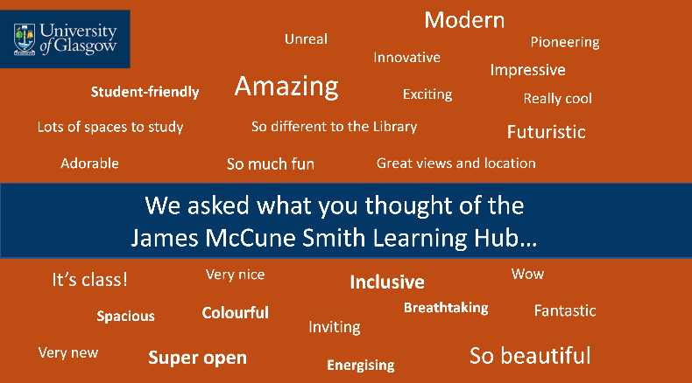

The Communications Team and the Information Office have responsibility for the James McCune Smith Learning Hub digital signage and video walls and will look to diversify usage and content in 2022.

Social Media
Followers have grown across the uofglibrary social channels, up to 11.5k on Twitter, 17.5K on Instagram and 8.7K on Facebook. These channels continue to be used to share important messages and good news, and to interact with followers including students, staff, and members of the wider public.

Acknowledgements
This has been an incredibly challenging year and we would like to record in this report our huge thanks to all Information Services staff who have shown their creativity, commitment and diligence in delivering services and support to the University community over the past year. We would also like to thank our colleagues across the University community who have partnered with and supported us throughout the year.

===

