Making Word documents accessible
To make a document accessible, follow the six principles of SCULPT:
- Structure
- Colour
- Use of Images
- Links
- Plain English
- Tables
These principles are also outlined on the University of Glasgow Digital Accessibility page.

Structure

Headings
Headings in Word give the document a logical structure. This structure allows the document to be navigated and reorganised easily, for example, Video: using Word with a screen reader.
A typical Word document will have a hierarchy of:
- Heading 1 as the document title and should be used only once.
- Heading 2 is a section heading.
- Heading 3 is a sub-section
- Body text.
It is important not to jump heading levels, such as going from Heading 1 to Heading 3, as this affects navigation.
Try to use as few subheadings as possible without sacrificing the clarity of the page.

Creating a Heading
Select the text for the heading.
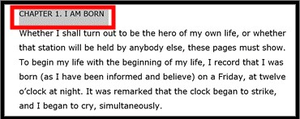
From the Home tab, select Styles.
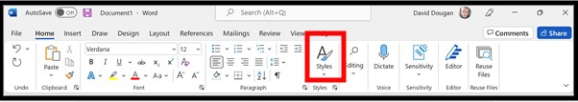
Choose the appropriate Heading level for your text.
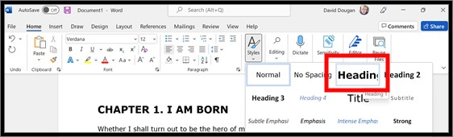
The Heading will be changed to match the chosen Style.

Further structural elements in Word
- Use sans serif fonts (for example; Arial, Helvetica, Verdana, and Calibri);
- Consider using Open Dyslexic font free download;
- Use a minimum font size of 12 pts;
- Use brief paragraphs and sentences;
- Use bullet points;
- Use page numbers;
- Include a table of contents for long documents;
- Include summaries for long documents.

Going Further with Headings
Headings can be used to:
- Video: Create a Table of Contents;
- Video:Change the heading levels – for example, a subsection can be promoted to a section or the headings used to navigate a document;

Colour
- Ensure that there is sufficient contrast between the text colour and the background colour.
- Choose Automatic as the text colour to ensure the text will be readable in High Contrast Mode or Inverted Mode
- If you do use colour in a Word document, try looking at your document in grayscale to check for sufficient contrast.

How to Use Color Filters in Windows 11 (howto geek)

Using Colour Filters in MacOS (apple.com)

Going Further with Colour
- Color Contrast Checker - TPGi
- WebAIM: Contrast Checker

Links
Add meaningful hyperlink text. Links should describe the destination of the link.
For example, instead of hyperlinking the text ‘Click here’, include the full title of the destination page: ‘University of Glasgow - MyGlasgow - Digital Accessibility.’

Going Further with Links
- Creating links in Microsoft Word (microsoft.com)

Use of Images
Include alternative text with all visuals that convey information.
Briefly describe the image. Imagine trying to describe the image over the phone.
Avoid using text in images as the sole method of conveying information. If you must use an image with text in it, repeat that text in the document.

Going further with Alt Text
- Alt Text creation advice (gov.uk)

Plain English
- Consider the level of study or knowledge of your audience;
- Explain all acronyms, for example, “. . . the Learning Innovation Support Unit (LISU)”;
- Explain complex terms in a glossary or define them when you first use them.

Going Further with Plain English
- Microsoft Editor, spelling and grammar checker (microsoft.com)

Tables
- Use a simple table structure and include column headers;
- Avoid the use of split cells, merged cells, or nested tables;
- Don't have any completely blank rows or columns;
- Include a Header row for your table;
- Add alt text to your table;
- Check that you can navigate the table by the Tab key.
Highest Qualification | Estimate (%)  June 2018 to June 2019
Degree or equivalent | 20.6
Higher education | 16.1
GCE A level or equivalent | 17.5
GCSE grades C and higher or equivalent | 18.1
Other qualification | 6.3
No qualification | 21.4

Highest level of qualification of disabled people aged 21 to 64 in Scotland.
Disability and education - Office for National Statistics (ons.gov.uk)

Going Further with Tables
- Video: Create accessible tables in Word (microsoft.com)

Checking Your Content: using Word’s Accessibility Checker
The checker tells you how to fix any issues it finds:

Errors
Content that will be impossible, or very difficult, for someone with a disability or assistive technology (e.g. a screen reader) to use

Warnings
Content that will likely be understood, but with difficulty

Tips
Suggestions that will improve the experience for users
This link contains a full list of the accessibility rules (microsoft.com) that could generate an error message.
It is important to remember that the Accessibility Checker is not perfect, and a human check is the best way to identify SCULPT accessibility issues.

How to use the Accessibility Checker
Create your document with the accessibility checker open from the start.
To start, click Review > Check Accessibility:
If your document has accessibility issues the checker will:
- Categorise issues by severity
- Tell you how to resolve each issue
- Allow you to click each issue to jump directly to its location
- Explain the impact of each issue for your students
When your document is free of issues, you will be told: ‘No accessibility issues found. People with disabilities should not have difficulty reading this document.’

